***Business Reason***

Users should be able to create “New/New” and “New From Competitor” quotes without creating a 403 error.

***Task Requirements***

1. Find root cause of the 403 error and fix it so users can click “Next” and move through the quote flow as they did before the upgrade.
2. Customer support found that the 403 error was the result of the following tag found inside the geoCodeForCustomerAddress_quote attribute:”<FormattedAddress>”
3. The error comes when we write the tag back to the attribute. The tag is written back to the attribute in the default for the attribute.
4. The attribute is set to the outputXML.

***Build Plan***

1. Replace the <FormattedAddress> tag with <FAddress> right before the return statement in the default of the geoCodeForCustomerAddress_quote attribute.
   1. Here is the new default code:

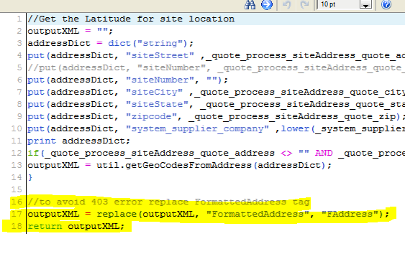

1. Save the default
2. Make the attribute always set to default.
   1. Modify tab, select “Revert to Default” for all quote, line, and process actions
3. Save the attribute
4. Deploy Commerce
5. Unit Test
   1. Create “New/New” and “New From Competitor” quotes from end to end without hitting a 403 error
   2. Confirm the open and close tags match in the quote XML

***Admin Guide Changes***

A 403 error will be thrown if we use “<FormattedAddress>” in the quote XML. The geoCodeForCustomerAddress_quote attribute used to use that tag. Thus, we changed the default of the attribute so that we replace the bad tag with “<FAddress>” before we write the value back to the attribute. Please see the build plan for the specific code change.

***User Guide Changes***

None.